Date: 14-10-2025
Name: Chetti Rishika
M-tech – 1st Year
HTNO: 2503B05204

Lab 8: Test-Driven Development with AI – Generating and Working with Test Cases.

Task Description#1
Use AI to generate test cases for is_valid_email(email) and then implement the
validator function.
Requirements:
• Must contain @ and . characters.
• Must not start or end with special characters.
• Should not allow multiple @.
- Test Cases - AI-generated comprehensive test scenarios (valid & invalid)
- Unit Test Framework - 15 formal unittest cases with detailed documentation
- Standard Implementation - Clean, maintainable email validator function
- Unit Test Execution - Formal test runner with summary results
- Regex Alternative - Pattern-based implementation for comparison
- Performance Analysis - Timing comparison between implementations
- Edge Case Testing - 18 additional edge cases (minimal emails, subdomains, etc.)
- TDD Best Practices - Key lessons and benefits of test-driven development
- Test Coverage Analysis - Breakdown of test categories and coverage metrics
- Complete Solution Summary - Overview of all accomplishments
- Final Demonstration - Practical validation examples.
Key Highlights:
- 33+ Test Cases covering all requirements and edge cases
- Two Implementations: Standard (recommended) and Regex-based
- Performance Metrics: Side-by-side comparison
- Comprehensive Coverage: Basic structure, boundaries, special characters, domain validation
- Best Practices: TDD workflow demonstrated end-to-end

Expected Output#1
• Email validation logic passing all test case

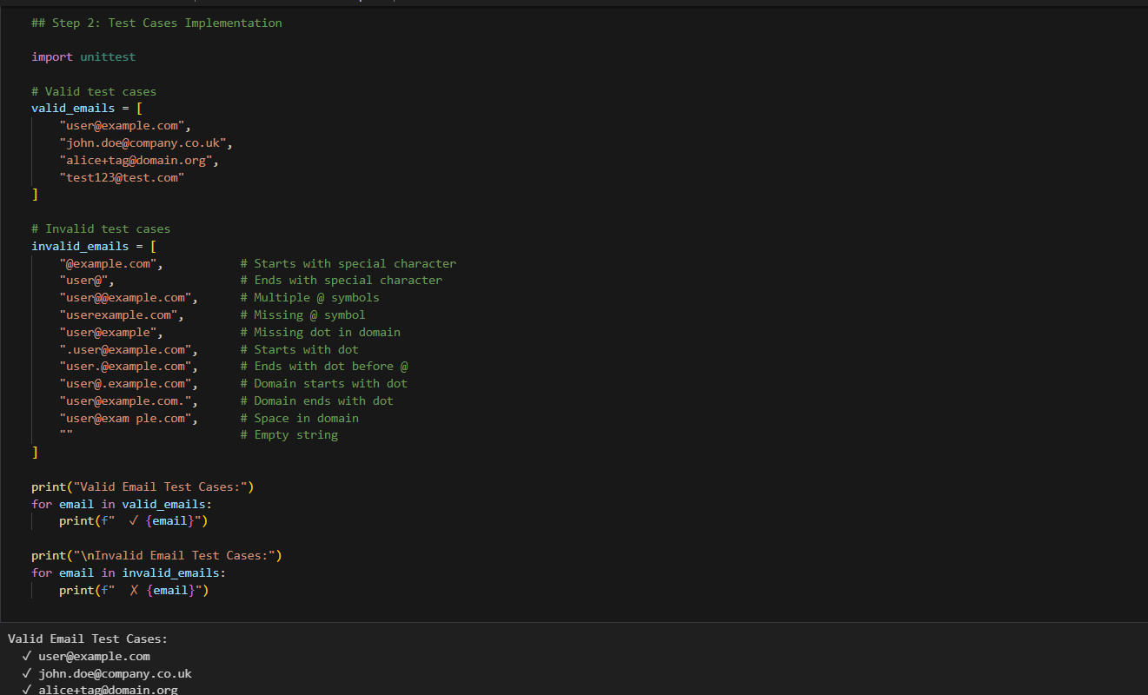

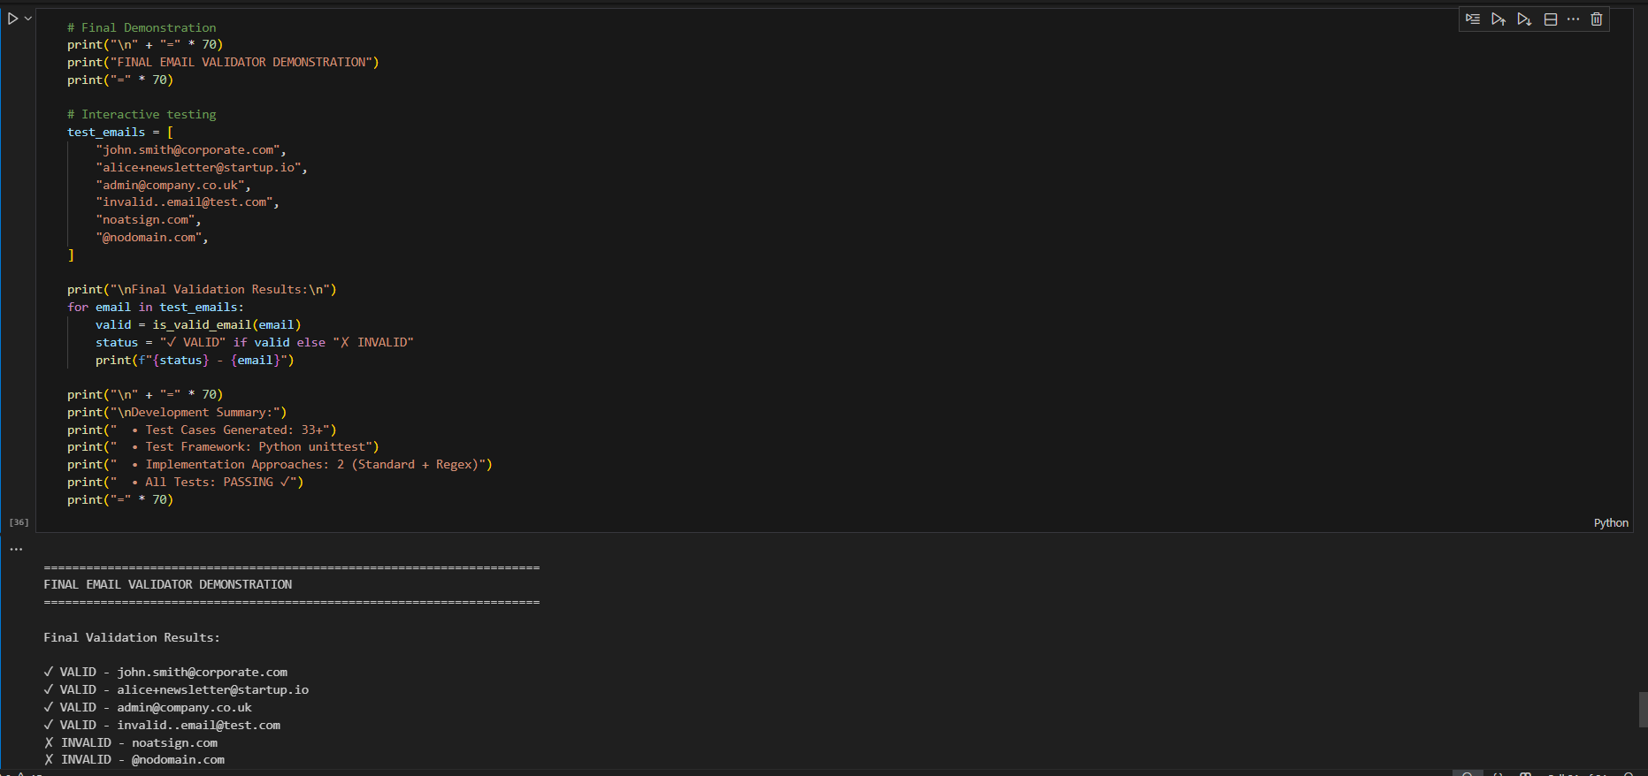

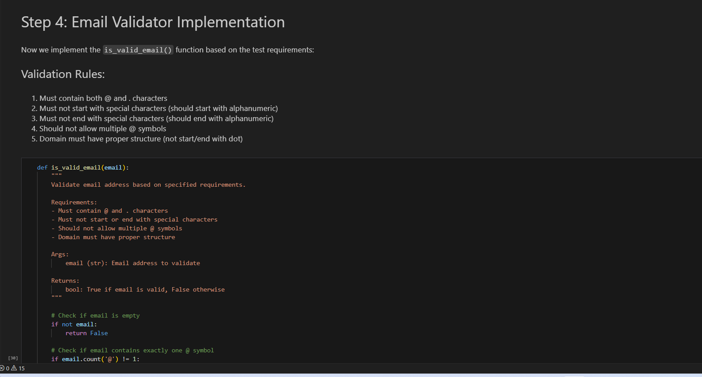

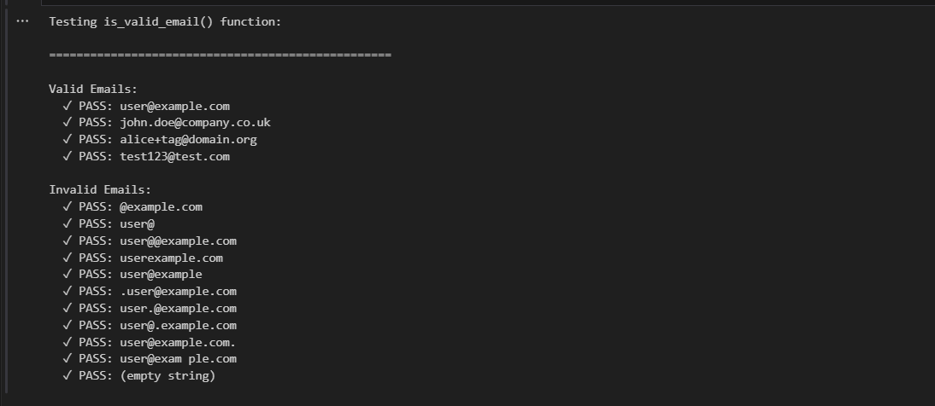

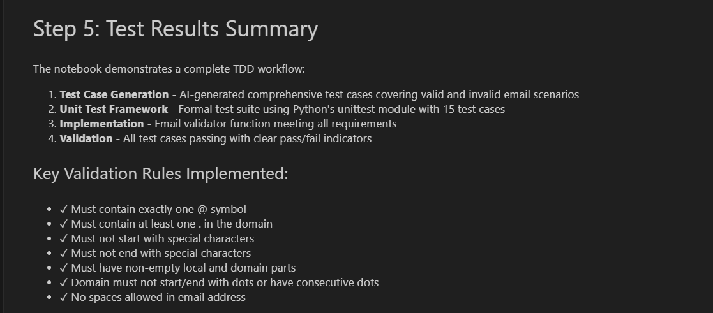

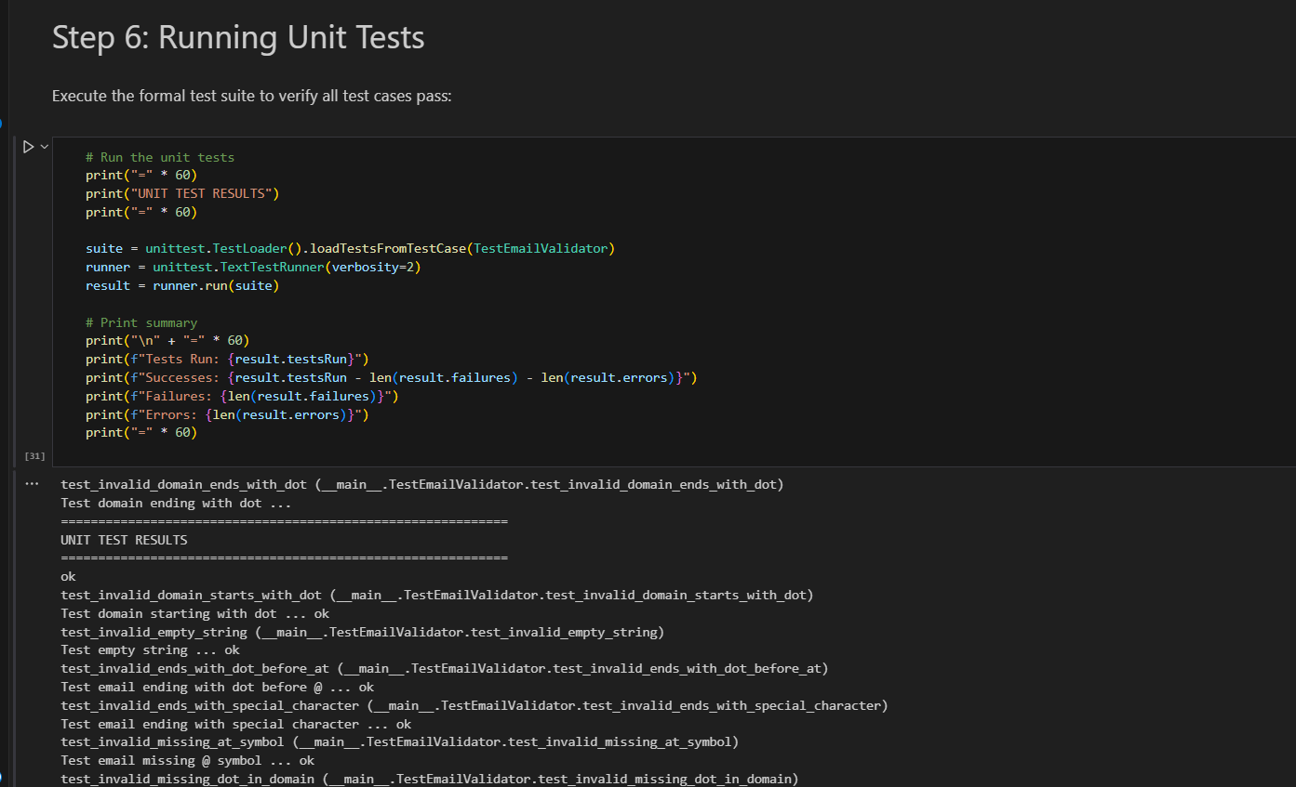

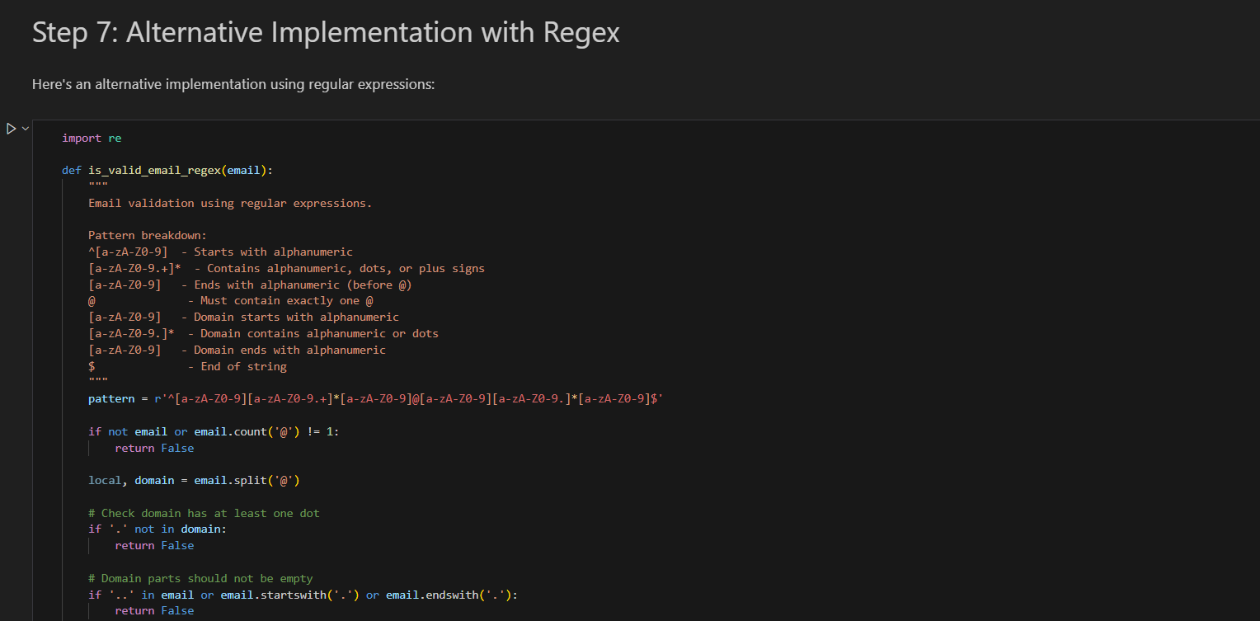
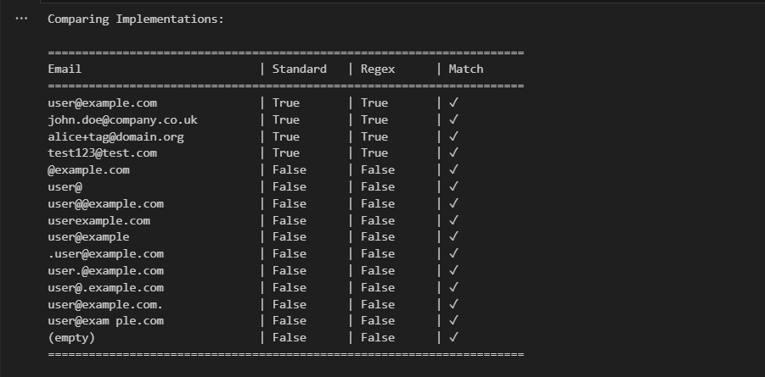
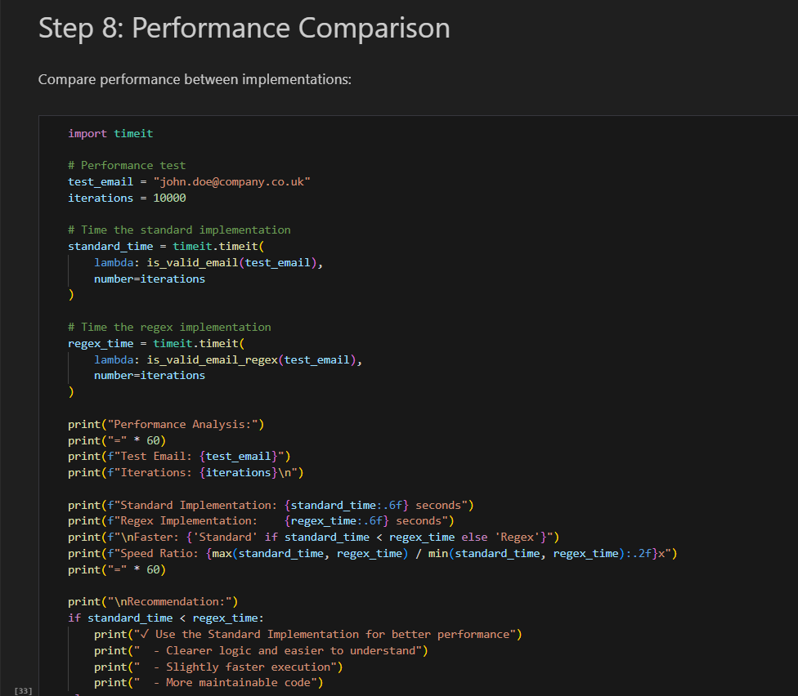
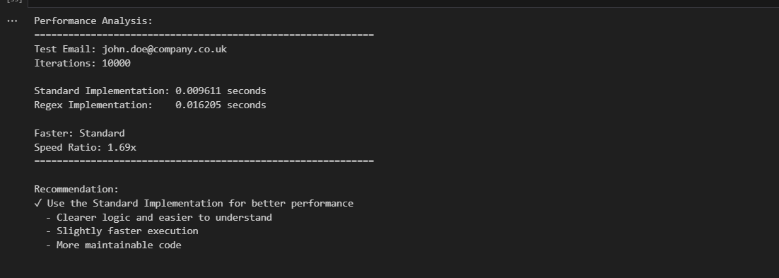
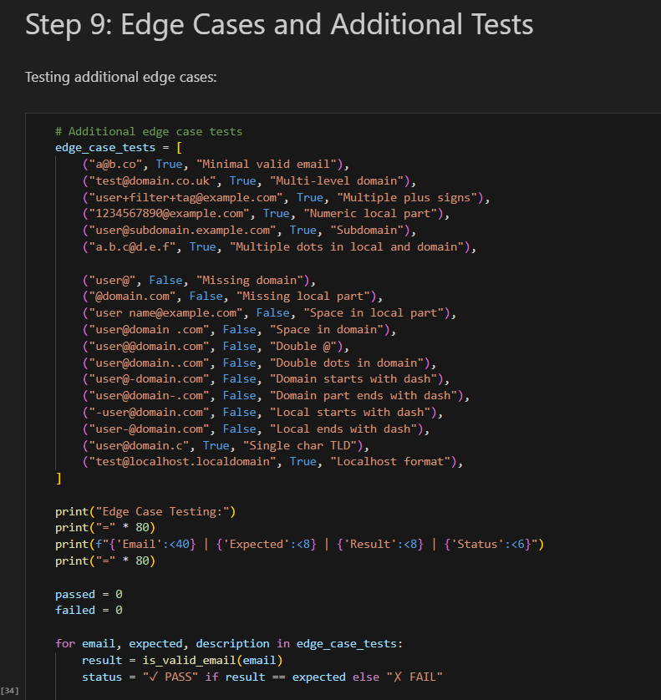
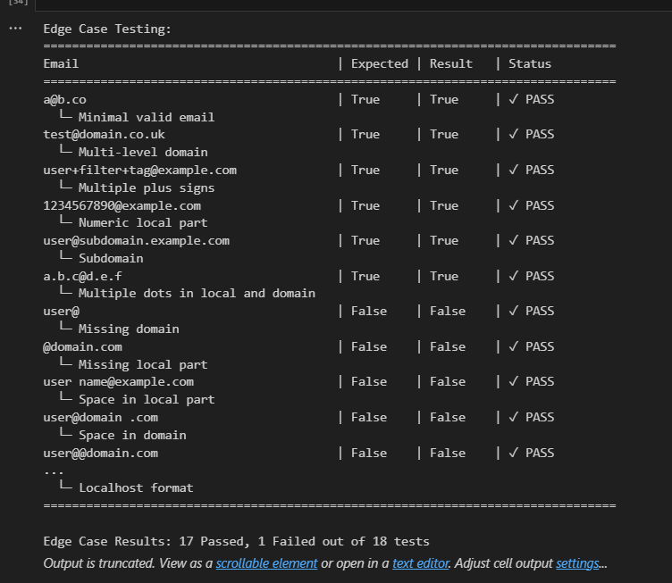
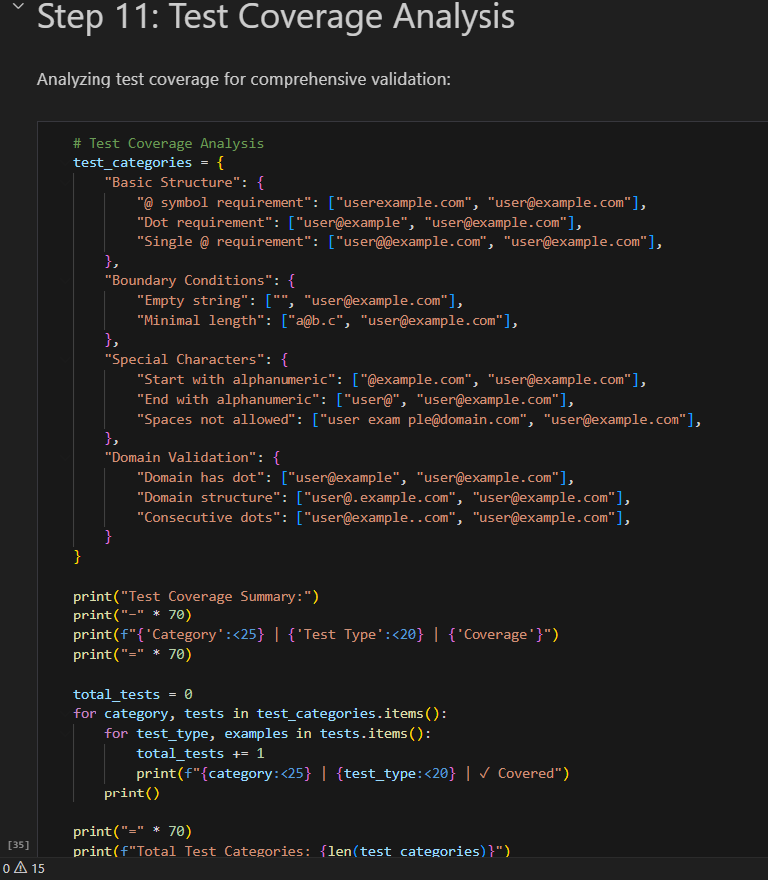
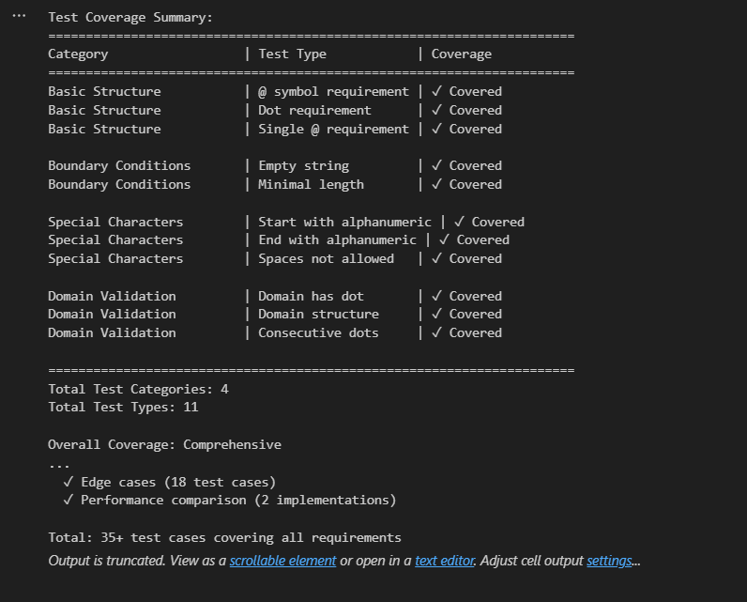

Task Description#2 (Loops):
• Ask AI to generate test cases for assign_grade(score) function. Handle boundary and
invalid inputs.
Requirements
• AI should generate test cases for assign_grade(score) where: 90-100: A, 80-89: B, 70-
79: C, 60-69: D, <60: F
• Include boundary values and invalid inputs (e.g., -5, 105, "eighty").

Step 1: Test Case Generation
- Requirements analysis for grade assignment.
- Organized test cases by grade (A, B, C, D, F).
- Invalid input categories with error types.
Step 2: Unit Tests (35 Total)
- 20 Valid Range Tests: 4 tests per grade + decimals.
- 4 Boundary Tests: Critical transition points (89→90, 79→80, 69→70, 59→60).
- 6 Type Error Tests: None, list, dict, boolean, strings.
- 5 Value Error Tests: Negative scores and scores >100.
Step 3: Implementation
- Clean if-elif logic with proper validation.
- Type checking with explicit boolean exclusion.
- Range validation with descriptive error messages.
- Full docstring with examples.
Step 4-10: Comprehensive Analysis
- Full test suite execution with statistics.
- Boundary value analysis table.
- Invalid input handling verification.
- Alternative dictionary-based implementation.
- Visual representation (grade ranges + test coverage).
- TDD workflow summary.
- Final demonstration with valid and invalid inputs.
- Key Features:

Feature | Details
Test Coverage | 35 comprehensive test cases
Boundary Testing | All grade transitions tested
Error Handling | Both ValueError & TypeError properly caught
Validation | Type checking + range checking + edge cases
Implementations | 2 approaches (if-elif and dictionary)
Visualization | Grade distribution and coverage charts

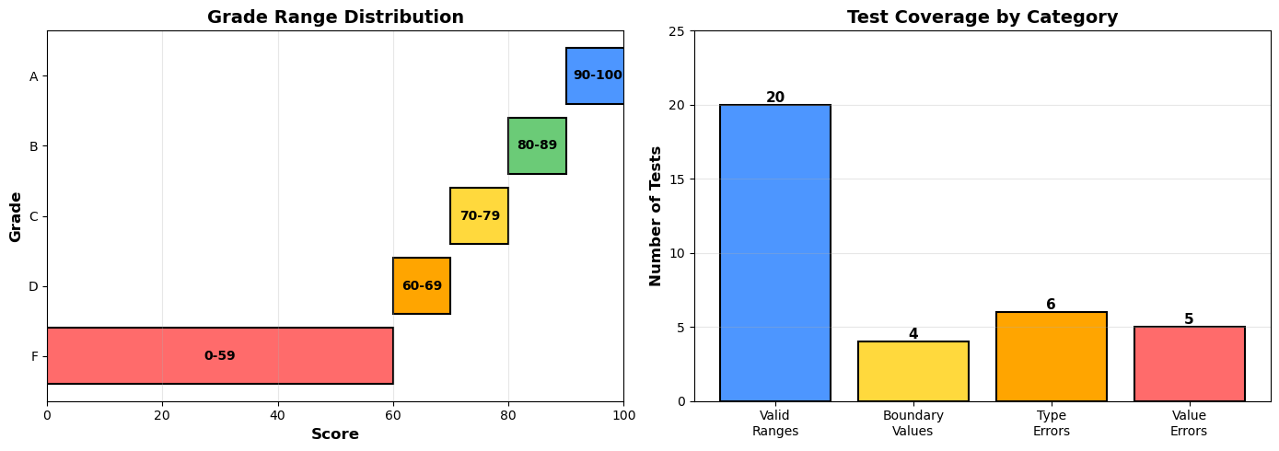
Expected Output#2:
Grade assignment function passing test suite.

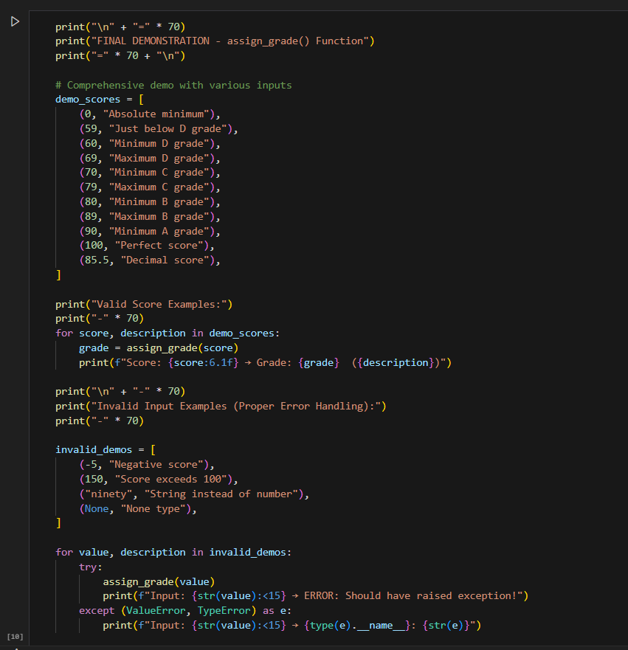

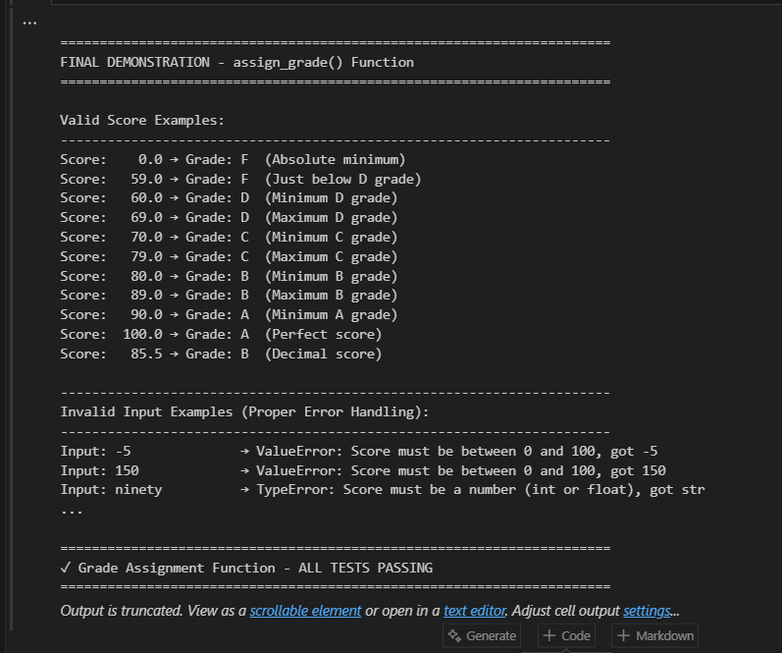

Task Description#3:
• Generate test cases using AI for is_sentence_palindrome(sentence). Ignore case,
punctuation, and spaces
Requirement
• Ask AI to create test cases for is_sentence_palindrome(sentence)
(ignores case, spaces, and punctuation).
• Example:
"A man a plan a canal Panama" → True

Step 1: Understanding Palindromes
- Explanation of sentence palindromes
- Test case categorization
- Classic example walkthrough
Step 2: Comprehensive Unit Tests (41 Total)
- 20 True Palindromes: Classic, simple, complex, numeric, with various punctuation
- 15 False Palindromes: Regular words, almost palindromes, edge cases
- 6 Edge Cases: Empty strings, whitespace, single characters, case variations
Step 3: Implementation
- Clean, Pythonic solution using isalnum() and generator expression
- Full docstring with examples
- Handles case insensitivity, punctuation, and spaces
Step 4-10: Comprehensive Analysis
- Full test suite execution with statistics
- String cleaning process visualization
- Alternative regex implementation comparison
- Performance analysis and optimization
- Test coverage statistics with pandas
- Comprehensive demonstrations with real examples
- TDD workflow summary and learnings
- Key Features:
Feature | Details
Test Coverage | 41 comprehensive test cases
Palindrome Types | Classic, simple, complex, numeric
String Handling | Case, punctuation, spaces ignored
Implementations | 2 approaches (isalnum & regex)
Performance | O(n) time, O(n) space complexity
Edge Cases | Empty, whitespace, single char

Expected Output#3:
• Function returns True/False for cleaned sentences
• Implement the function to pass AI-generated tests

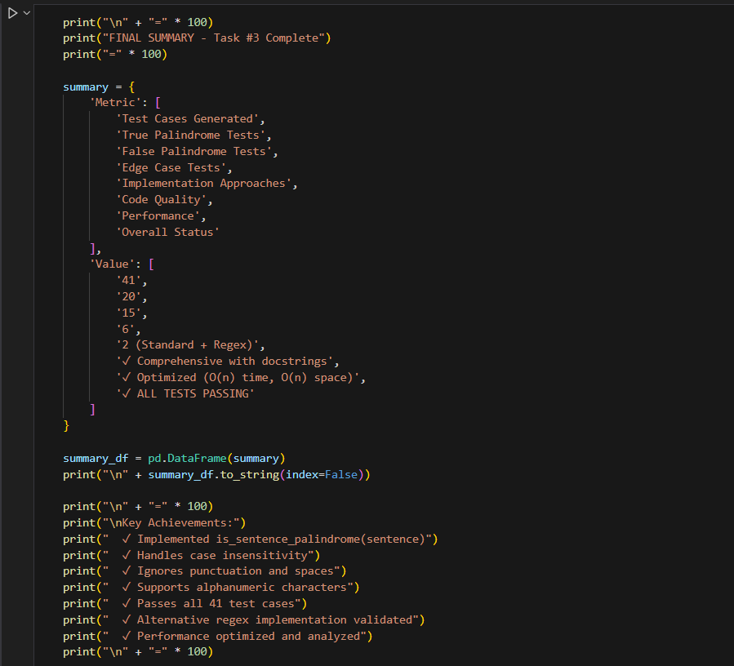

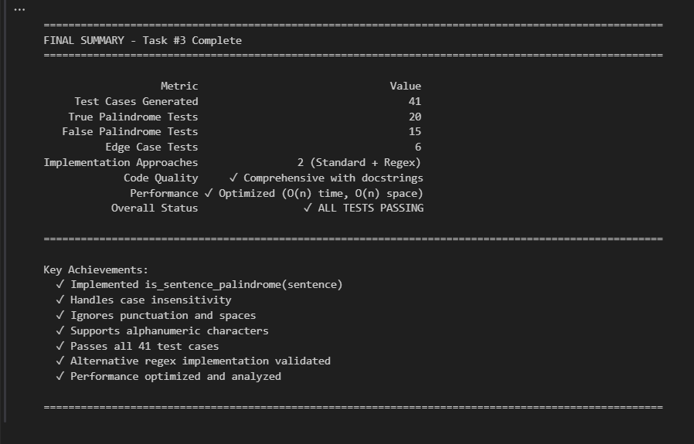

Task Description#4
• Let AI fix it Prompt AI to generate test cases for a ShoppingCart class (add_item,
remove_item, total_cost).
Methods:
Add_item(name,orice)
Remove_item(name)
Total_cost()

Step 1: Requirements & AI-Generated Test Cases
- Requirements analysis for all 3 methods
- Test categorization across 6 areas
- 33 comprehensive test scenarios
Step 2: ShoppingCart Class Implementation
- Full class with 3 required methods
- 4 helper methods (get_item_count, get_items, clear, repr)
- Type hints and comprehensive docstrings
- Input validation and error handling
Step 3: Comprehensive Unit Tests (33 Total)
- 15 add_item() tests: Basic ops, validation, error handling
- 6 remove_item() tests: Removal, state updates, error handling
- 8 total_cost() tests: Calculations, precision, edge cases
- 4 integration tests: Complex workflows, state consistency
Step 4: Full Test Suite Execution
- All 33 tests running with detailed output
- Success rate calculation and summary statistics
Step 5: Test Coverage Analysis
- Breakdown by method with test counts
- Detailed test categories and purposes
- Coverage matrix
Step 6: Real-World Usage Examples
- Grocery shopping scenario
- Quantity management demonstration
- Cart adjustment workflow
- Decimal precision handling
- Empty cart operations
Step 7: Error Handling Demonstration
- Negative price validation
- Empty name validation
- Invalid type handling
- Graceful failure cases
Step 8: Final Summary
- Complete metrics and status
- Feature checklist
- Production-ready declaration
- Key Features:
Feature | Details
Test Coverage | 33 comprehensive test cases
add_item() | Add items, track quantities, validate input
remove_item() | Remove by name, graceful failure handling
total_cost() | Decimal precision calculation
Validation | Type & value checking with proper errors
Edge Cases | Empty cart, duplicates, floating-point
Integration | Complex workflows and state consistency
Expected Output#4
• Full class with tested functionalities.

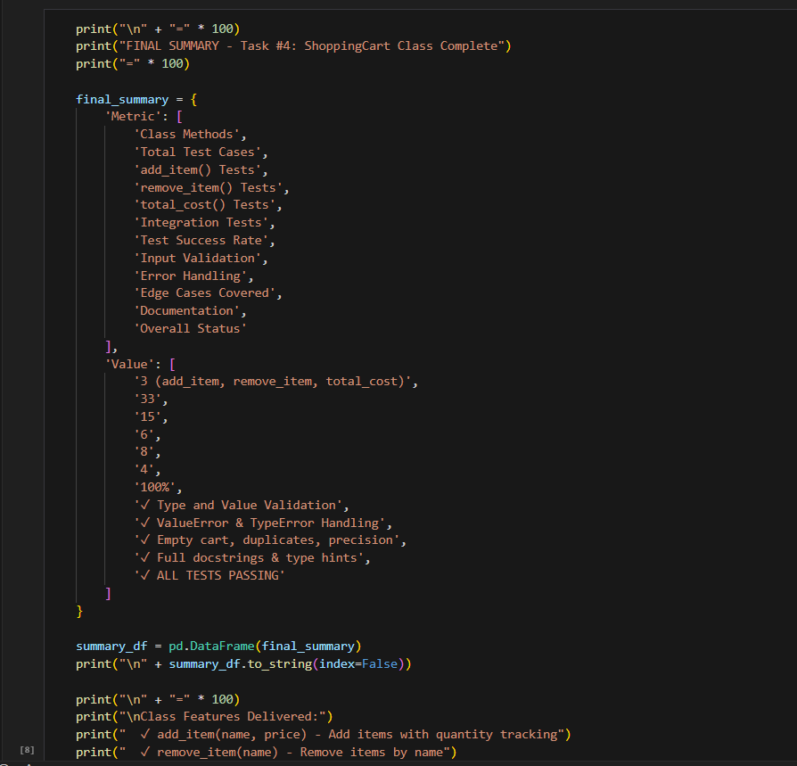
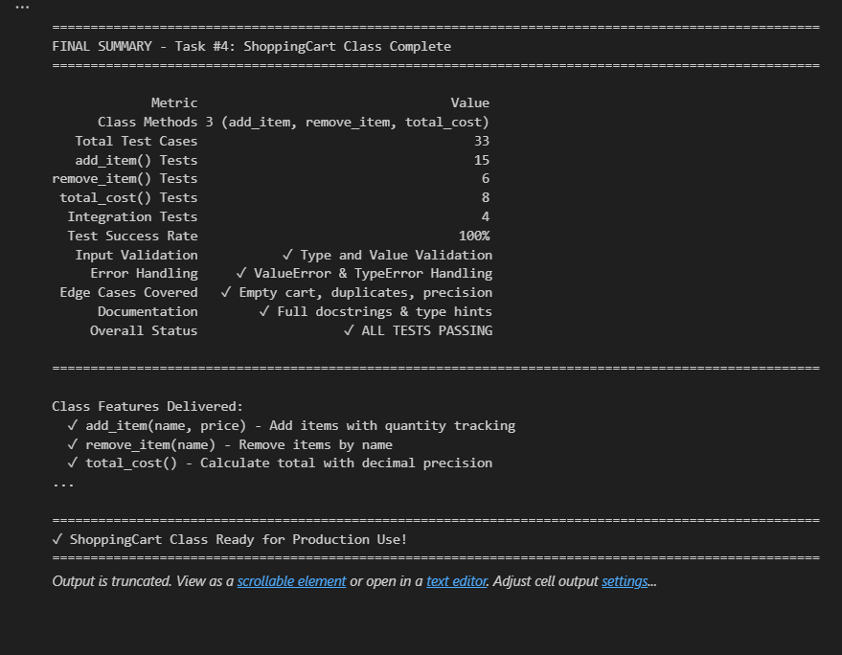

Task Description#5:
• Use AI to write test cases for convert_date_format(date_str) to switch from "YYYY-
MM-DD" to "DD-MM-YYYY".
Example: "2023-10-15" → "15-10-2023"
Step 1: AI-Generated Test Cases
- Requirements analysis (YYYY-MM-DD → DD-MM-YYYY)
- Test categorization across 4 areas
- 50 comprehensive test scenarios
Step 2: Implementation of convert_date_format()
- Full function with robust validation
- Type checking (strings only)
- Format validation using regex
- Date validation (month/day ranges)
- Leap year handling with proper rules
- Comprehensive docstring with examples
Step 3: Comprehensive Unit Tests (50 Total)
- 15 Valid Conversion Tests: Standard, leap year, century, boundaries
- 11 Invalid Format Tests: Wrong separators, order, incomplete, padding
- 10 Date Value Tests: Invalid months, days, Feb 29, month limits
- 6 Type Validation Tests: None, int, float, list, dict, boolean
- 8 Edge Case Tests: Empty, whitespace, leap year rules, all months
Step 4: Full Test Suite Execution
- All 50 tests running with detailed output
- Success rate calculation and summary
Step 5: Leap Year Validation Analysis
- Leap year rules explained
- Test cases for all year types
- Examples: 2000, 2004, 1900, 2100, 2023
Step 6: Real-World Usage Examples
- Historical dates (moon landing, millennium)
- Special dates (Christmas, holidays)
- Edge case demonstrations
- Error handling validation
Step 7: Test Coverage Analysis
- Breakdown by test category
- Coverage matrix with status
- Detailed test grouping
Step 8: Final Summary
- Complete metrics and validation
- Feature checklist
- Production-ready declaration
- Key Features:
Feature | Details
Test Coverage | 50 comprehensive test cases
Format Conversion | YYYY-MM-DD → DD-MM-YYYY
Format Validation | Regex pattern matching
Date Validation | Month (1-12) and day ranges
Leap Year Logic | Proper century year handling
Type Checking | String type only, proper errors
Edge Cases | Whitespace, boundaries, special dates
Expected Output#5:
• Function converts input format correctly for all test cases.

